**Modeling real-world problems with linear inequalities**

Imagine you're planning a road trip with a budget of $200 for fuel. The cost of gas is $4 per liter, and your car's fuel efficiency is 20 km per liter. You need to figure out the maximum distance you can travel without exceeding your budget. This is a practical situation where understanding and solving inequalities becomes essential. Inequalities help us make informed decisions by providing a way to evaluate and compare different possibilities within given constraints. In this article, we will explore how inequalities work and how they can be applied to real-life scenarios like this one.

**What is an inequality?**

Inequalities are like equations, but instead of showing that two things are equal, they show that one thing is bigger, smaller, or at most equal to another. We use these symbols when writing inequalities:

* > means "greater than"
* < means "less than"
* ≥ means "greater than or equal to"
* ≤ means "less than or equal to"

Let's see how we can model an inequality for the road trip scenario.

1. Assemble the data
   1. Your car's fuel efficiency is 20 km per liter.
   2. The cost of gas is $4 per liter.
   3. You have a budget of $200.
2. Assign letters for the variables: Let **d** be the distance you can travel in miles.
3. Model the inequality:

* The total cost of gas should be **less than or equal** to $200.
* The liters of gas required would be $\frac{d}{20}$
* This gives us the inequality:

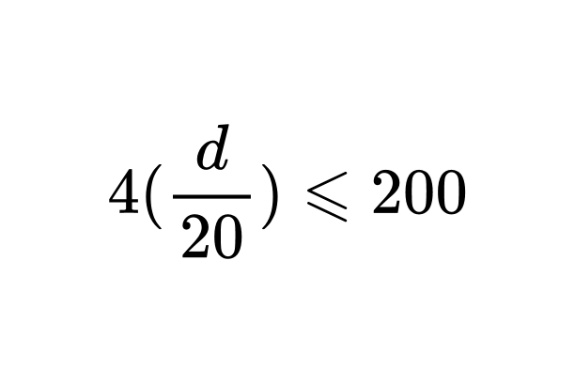

1. Solve the inequality:

* We can solve inequalities in a similar approach to solving linear equations.
* The objective is to isolate the variable on one side of the inequality by carrying out inverse operations.
* A key difference when dealing with inequalities is that when you divide or multiply an inequality by a negative number the inequality sign flips.
* Let’s solve the inequality we got for the road trip .

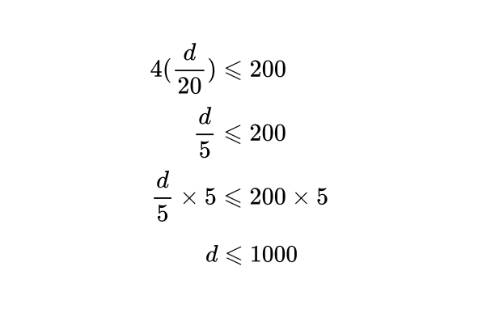

* This determines that you are able to travel up to 1000 km without exceeding your budget.

**Real-world scenarios**

1. **Budgeting: Figuring out how much you can spend without exceeding your budget.**

You have $50 for a week’s allowance. If you want to buy a book that costs $30, you use an inequality to see how much you can spend on other things:

$x+30≤50$

1. **Traveling: Ensuring you don’t exceed a certain weight limit in your luggage when traveling by air plane.**

Your luggage currently weighs 35kg, but the airline limit is 20kg. You need to remove some weight **w** to comply with the limit.

$35-w≤20$

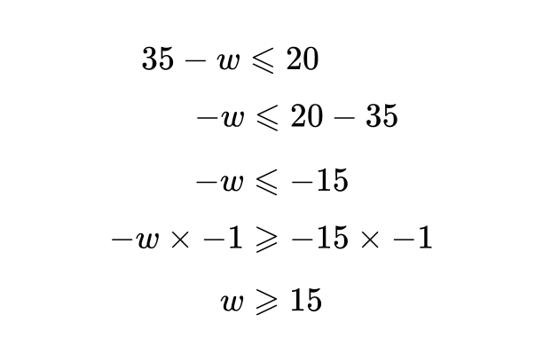

When we solve this inequality we have to divide both sides by -1. Note that the inequality sign flips as mentioned earlier.

In conclusion, must remove at least 15kg of luggage to stay within the weight limit.

1. **Cooking and Baking: Instructions in recipes can be represented using inequalities**.

The instructions for a cake recipe mention the cake must be baked for at least 25 minutes but under 30 minutes. We can represent the constraints for the baking time using an inequality.

$25≤ b<30$